ABOUT THE BRAND
The Tapa Co. is a dharmic lifestyle brand built on one insight: the problem isn’t access to rituals, it’s access to trusted guidance. Most Indians want to perform their rituals correctly but are caught between fear, confusion, and commercially motivated misinformation.
The brand sits at the intersection of scriptural authenticity and modern accessibility. It is not a puja store. It is not a pandit booking app. It is a knowledge-first, devotion-over-fear platform built on clarity and on the physical and service products that follow from that clarity.

What’s HELD US
Sanatana Dharma has outlasted empires, invasions and centuries of upheaval, not because institutions defended it, but because families carried it.
A grandmother explaining why a vrat is kept. A father at his morning puja before the day begins. Stories told at home that turned out, years later, to have been the real education. This is how it survived. Not in archives. At dinner tables, during daily pujas, watching Ramayana in groups.
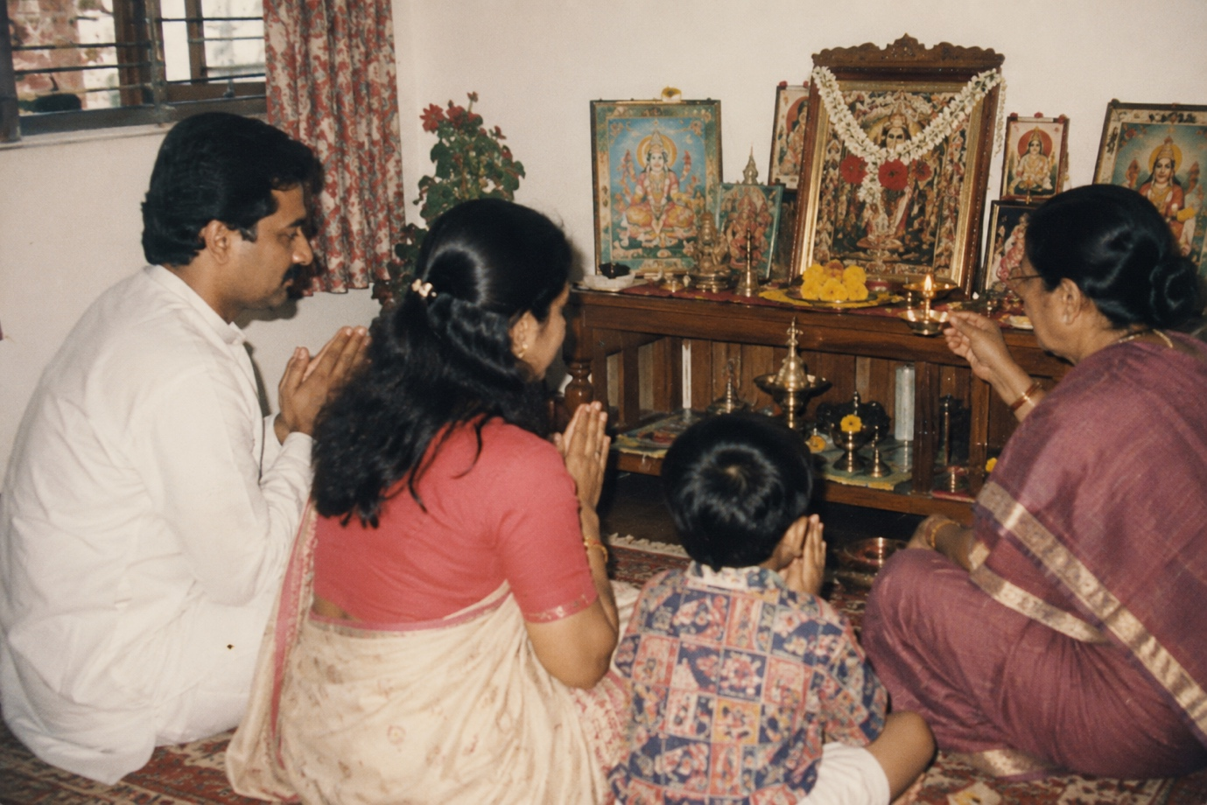

What’s Breaking
That handover is failing, and it is failing fast.
Families have scattered across cities and continents. The elder who once answered the question is a video call away, if at all or no longer there. But the wish to practise hasn’t gone anywhere. More people are turning towards their traditions today, not fewer.
They are simply learning them from strangers.

What Filled the Gap
Where trusted guidance is missing, confusion becomes easy to sell.
A forwarded message warning what will befall a family that gets a date wrong. A reel that turns a tithi into an emergency. A remedy for every fear, conveniently priced. Slowly, practice starts to feel like a test one might fail and every uncertainty arrives with something to buy attached.
This is not what Dharma teaches. Dharma asked for sincerity, not anxiety. Somewhere in the noise, the simplicity of it got lost.

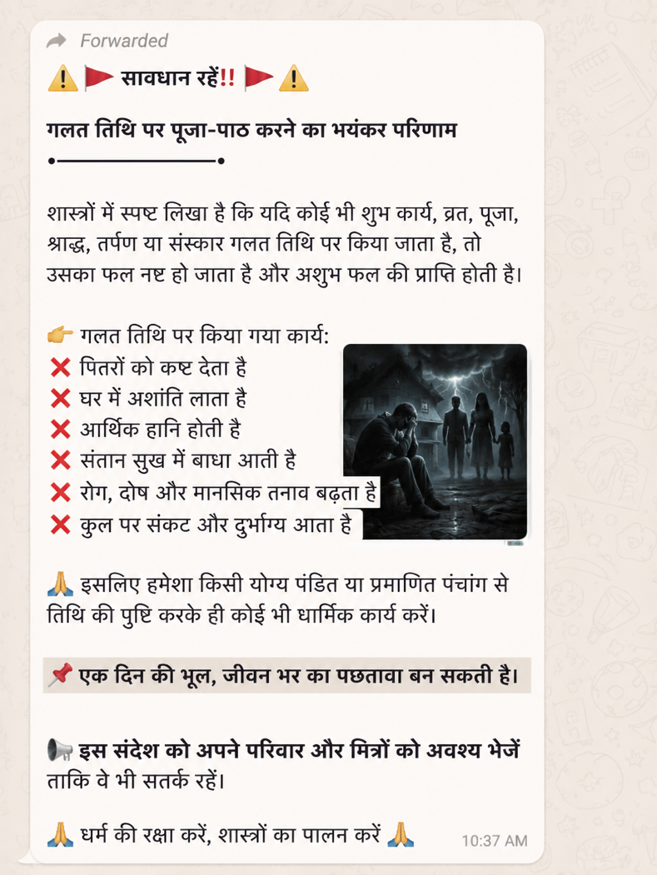

Why We Exist
The Tapa Co. was founded to give that clarity back.
We help people understand not just what to do, but why it matters, what scripture actually says, what is regional or family custom, and what is only fear wearing tradition’s clothes. All three deserve respect. They are not the same thing, and no one should have to guess which is which at eleven at night, alone with a phone.
Devotion doesn’t weaken under understanding. It steadies.

What We’re Building
- Ritual Guides: the complete vidhi, katha and samagri for a puja, explained and sourced
- Panchang: dates, tithis and vrat calendars, free of fear framing
- Pujan with Purohit: vetted purohits, everything required included
- Ritual Kits: assembled to the ritual, not to a price point

Each one is built so a person can practise with confidence, whether or not there is an elder in the next room.

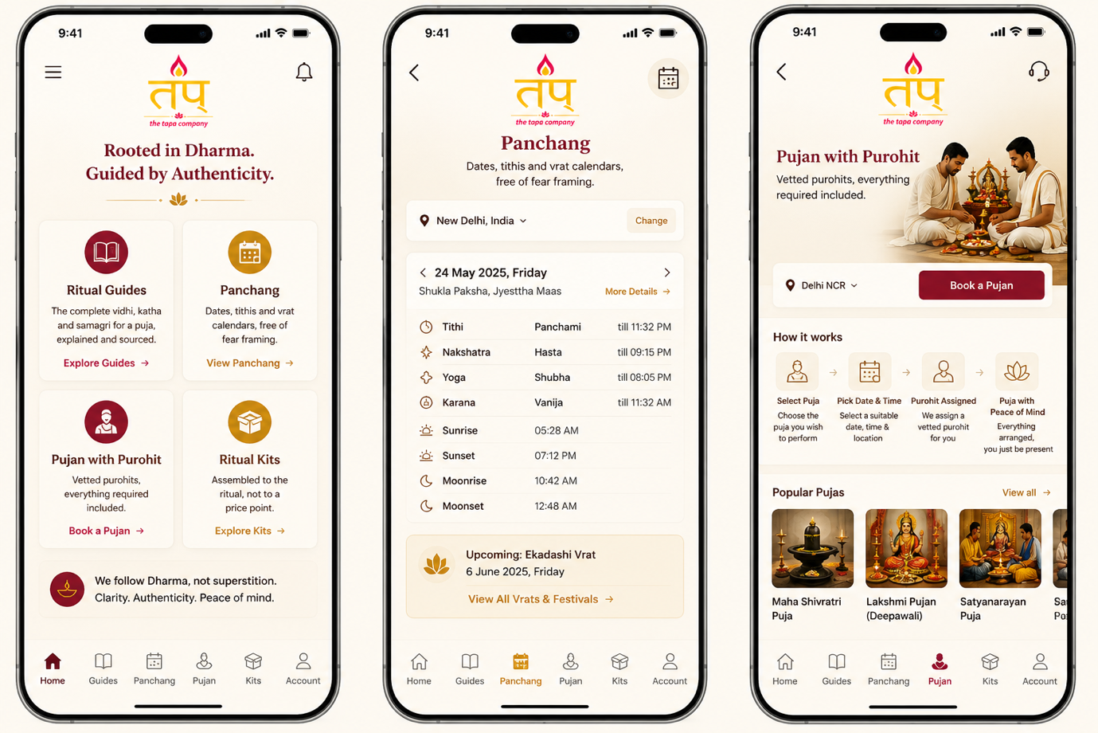

What Will Never Change
Dharma before business. Scripture before opinion. Knowledge before commerce. Authenticity before convenience.
Fear will never be our marketing strategy.
No individual, institution or company owns Dharma. Each one of us are students before we are builders.

Who’s Building It
Founded by Komal Gupta, nineteen years building consumer brands, including ShopClues into the unicorn club, KOOVS from bootstrapped startup to public listing, and Ferns N Petals from a single-market boutique to a $26M business across twelve countries. Before that, a journalist and documentary filmmaker.
Two decades of turning confusion into clarity, now pointed at something that matters more.

Follow us
thetapaco.com
Instagram thetapaco · LinkedIn /company/thetapaco · Facebook thetapaco. · YouTube thetapaco

